Item Purchase Tool
You need to implement a simple one-page application to allow the user to create a purchase.

Requirements:
- You need to create Custom Objects according to the Data Model
- All requirements represent as User Stories with useful links
- You can use only LWC components and Apex classes, Aura component you can use only as a container for LWC components if you need
- Cover Apex code by Unit Tests
- Create a repo on GitHub, try to commit the changes more often. Send GitHub Repo URL by email when the task was done.
- Create Admin user for dev@truesolv.com on Salesforce Dev Instance when the task was done
- Create an unmanaged package - Create and Upload an Unmanaged Package
- More information and links to documentation you can find in Tools Section

Get started Salesforce development and useful links

Data Model:
- Purchase__c - new custom object
  - Name - String
  - ClientId - Lookup to Account object
  - TotalItems - Number
  - GrandTotal - Number
- PurchaseLine__c - new custom object
  - PurchaseId - Master-Detail to Purchase__c
  - ItemId - Master-Detail to Item__c
  - Amount - Number
  - UnitCost - Number
- Item__c - new custom object
  - Name - String
  - Description - String
  - Type - Picklist
  - Family - Picklist
  - Image - Url - link to image
  - Price - Number
  - AvailableQuantity__c - Number
- User - standard object
  - IsManager - Boolean new custom field

How to create Custom Object and Fields

User stories:
- As a user, I can open an Item Purchase Tool page from Account layout (You need to put a button to Account layout that will open an Item Purchase Tool page in separate tab), the Account Object is not the same as the User object
  - Standard Account Object
- As a user, I can see Account Name, Number, Account Industry on the page
  - Data Binding in a Template
- As a user, I can filter the displayed items by Family and Type
- As a user, I can see the count of listed items on the screen in the filter section
  - Call Apex Method from LWC
  - Render Lists in LWC
  - Run code on load (ConnectedCallback)
- As a user, I can search for the item by Name and Description
- As a user, I can see item details in modal window (Details button on Item Tile), also I can see an image of the item based on the Image URL on the item, link to get below
  - Modal Window
  - LWC Record Edit Form
  - LWC Record View Form
- As a user, I can select an item and add it to Cart (Add button on Item Tile)
  - Show Toast message
- As a user, I can see items in the Cart (Cart button will open a modal with selected items in table view)
- As a user, I cannot add an item to the Cart when it is out of stock
- As a user, when checking out the Cart, the system should validate that enough quantity is available for every selected item. If checkout is successful, the available quantity of purchased items should be decreased accordingly
- As a user, I can check out a Cart (Checkout button on Cart Modal) This action will create Purchase and Purchase Line records.
- TotalItems and GrandTotal on Purchase__c object should be calculated automatically in a Trigger based on Purchase Line records.
  - Apex Trigger
- As a user, after checking out the cart I should be redirected to the standard Purchase layout to see created Purchase and Purchase Line records
- As a manager, I should have the ability to create a new item in the modal window. (Create an Item button. The button should be available only for users with IsManager__c = true)
  - Render DOM Elements Conditionally
- To fill out Image field on the Item object you need to send a request to the Unsplash API to get photos by a search query, here’s a step-by-step guide, where query = {Your Item Name} is the name of the created item and put the link to the Image field. To get the link:
  - Create an Unsplash Account and Register an App
    - Go to Unsplash Developers and sign in or create an account.
    - Register a new application to get your Access Key. You’ll use this key to authenticate API requests.
  - Get the Access Key
    - After registering, you’ll find your Access Key in your app’s settings. Keep it safe — you’ll need it in your API calls.
  - Search for Photos via API Endpoint
The Unsplash API provides a search endpoint:
Here’s an example of making a search request using cURL:
curl -H "Authorization: Client-ID YOUR_ACCESS_KEY" \
"https://api.unsplash.com/search/photos?query=apple"
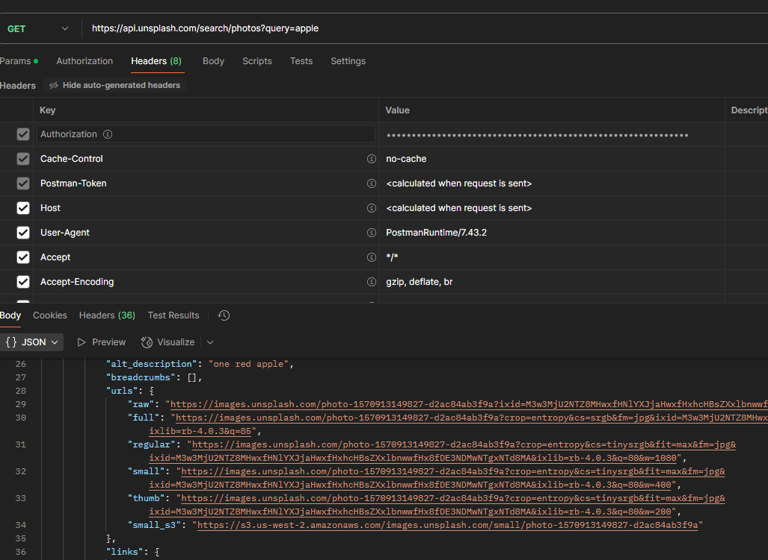

Tools:
- Salesforce Dev Org - Salesforce Developer Portal
- IDE - IntelliJ IDEA + JetForcer
- Backend - Apex - Apex Developer Guide
- Client-Side - LWC - LWC Docs
- Styles - Lightning Design System - SLDS

UI Mockup
